EXPERIMENT NO 6 DATE-21-4-2022

AIM: FAMILIARIZE WITH LINUX COMMANDS.

PROCEDURE

1]READ

To read the content of a line to a variable

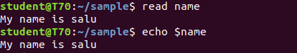

2]LOCATE
To find file or directory in other place.

3]locate -i

it is used in case insentive search
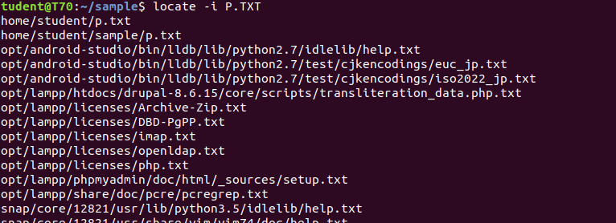

4]find
find file in a particular directory

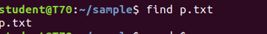

5]Grep

Grep commad will let you search through all the text in a given file

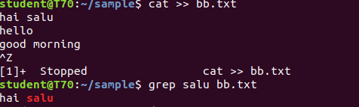

5.1]GREP -A1
To display the content and after the result.
5.2]GREP-B1
To display the before line of the content.
5.3]GREP -C1
Before and after lines are displayed.

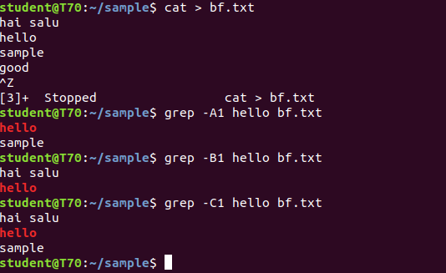

6]df

Is used to get a report on system disc

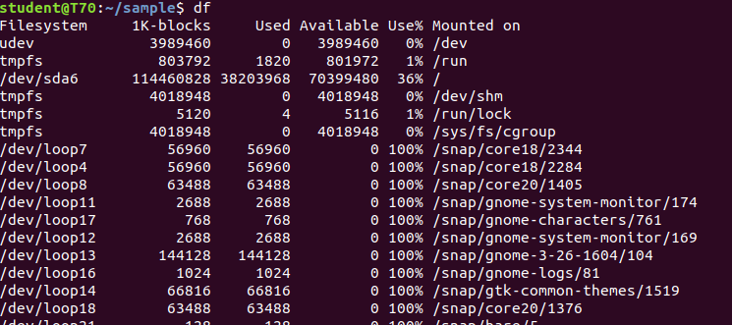

7]df -m

how many mega bytes used

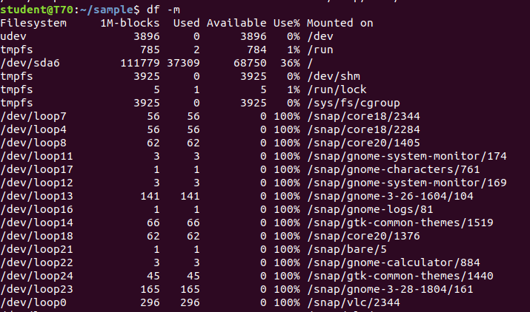

8]du

To check how much space a file in a current directory takes

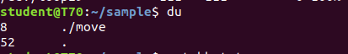

9]wc word count

used for counting purpose

9.1]wc -l filename.txt

9.2]wc -c filename.txt
9.3]wc -m filename.txt

9.4]wc -w filename.txt

grep -i filename

for an case insenstive search.

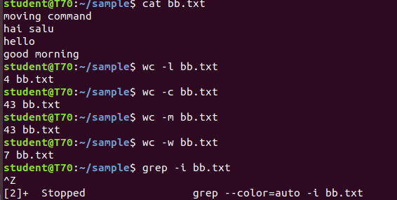
10]grep -v content filename.txt

Used inverted search

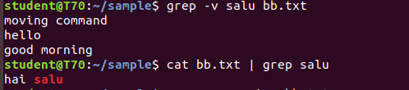

11] cat bb.txt | grep salu

Highlight word

